
Narrogin Senior High School
English Learning Area

EXAMINATION ANSWER BOOKLET

NAME: __________________________________________________

TEACHER: _______________________________________________

ENGLISH
YEAR 10
2018

INSTRUCTIONS TO CANDIDATES

Write all responses in this booklet.

Write the number of the question next to the beginning of your answer.

All writing must be done in blue or black pen only.

Do not remove pages from this answer book. Extra pages may be added.

SECTION |  | COMMENT
READING | /40
WRITING | /60

Time allowed for this paper
Reading time before commencing work: 5 minutes
Working time for paper: Two Lessons
Structure of this paper

Section | Number of questions available | Number of questions to be attempted | Suggested working time
Section One: Reading | 10 | 10 | One lesson
Section One: Writing | 2 | 1 | One lesson

Instructions to candidates:

1. The rules for the conduct of Semester Examinations are set by the school. Sitting this assessment implies that you agree to abide by these rules.

2. Write your answers in the standard answer book provided.

3. Your responses should address the specific requirements of the questions asked and you should follow any specific instructions given.

4. During the reading time you may not write.

SECTION ONE: READING & VIEWING

Allow approximately 50 minutes to complete this section. (40 marks)

Read the following extract and respond to the comprehension questions.

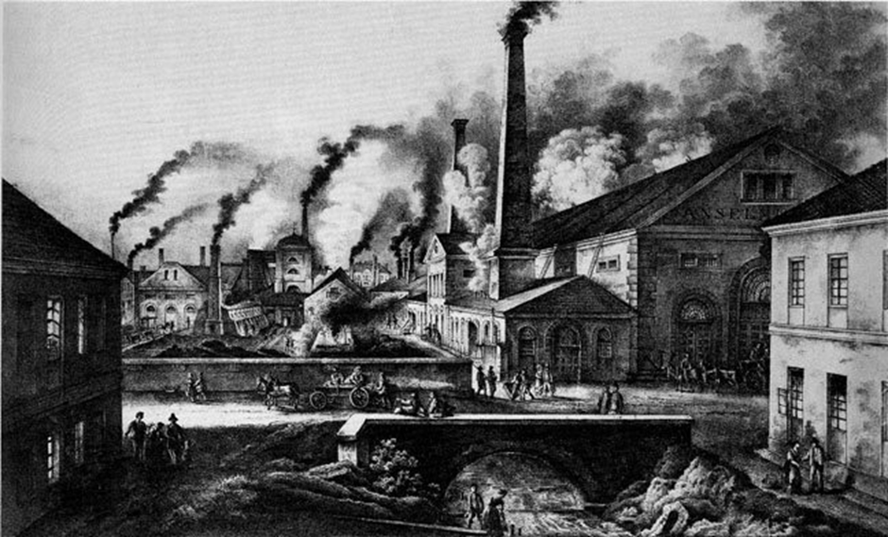

Source: Extract from The Great Towns by Friedrich Engels (1845).

Friedrich Engels was a German philosopher, social scientist, journalist and businessman who is credited with helping begin the communist movement with Karl Marx.

Every great city has one or more slums, where the working-class is crowded together. True, poverty often dwells in hidden alleys close to the palaces of the rich; but, in general, a separate territory has been assigned to it, where, removed from the sight of the happier classes, it may struggle along as it can. These slums are pretty equally arranged in all the great towns of England, the worst houses in the worst quarters of the towns; usually one- or two-storied cottages in long rows, perhaps with cellars used as dwellings, almost always irregularly built. These houses of three or four rooms and a kitchens form, throughout England, some parts of London excepted, the general dwellings of the working-class. The streets are generally unpaved, rough, dirty, filled with vegetable and animal refuse, without sewers or gutters, but supplied with foul, stagnant pools instead. Moreover, ventilation is impeded by the bad, confused method of building of the whole quarter, and since many human beings here live crowded into a small space, the atmosphere that prevails in these working-men's quarters may readily be imagined. Further, the streets serve as drying grounds in fine weather; lines are stretched across from house to house, and hung with wet clothing.

Let us investigate some of the slums in their order. London comes first, [4] and in London the famous rookery of St. Giles which is now, at last, about to be penetrated by a couple of broad streets. St. Giles is in the midst of the most populous part of the town, surrounded by broad, splendid avenues in which the gay world of London idles about, in the immediate neighbourhood of Oxford Street, Regent Street, of Trafalgar Square and the Strand. It is a disorderly collection of tall, three- or four-storied houses, with narrow, crooked, filthy streets, in which there is quite as much life as in the great thoroughfares of the town, except that, here, people of the working-class only are to be seen. A vegetable market is held in the street, baskets with vegetables and fruits, naturally all bad and hardly fit to use obstruct the sidewalk still further, and from these, as well as from the fish-dealers' stalls, arises a horrible smell. The houses are occupied from cellar to garret, filthy within and without, and their appearance is such that no human being could possibly wish to live in them.

But all this is nothing in comparison with the dwellings in the narrow courts and alleys between the streets, entered by covered passages between the houses, in which the filth and tottering ruin surpass all description. Scarcely a whole window-pane can be found, the walls are crumbling, door-posts and window-frames loose and broken, doors of old boards nailed together, or altogether wanting in this thieves' quarter, where no doors are needed, there being nothing to steal. Heaps of garbage and ashes lie in all directions, and the foul liquids emptied before the doors gather in stinking pools. Here live the poorest of the poor, the worst paid workers with thieves and the victims of prostitution indiscriminately huddled together, the majority Irish, or of Irish extraction, and those who have not yet sunk in the whirlpool of moral ruin which surrounds them, sinking daily deeper, losing daily more and more of their power to resist the demoralising influence of want, filth, and evil surroundings.

Nor is St. Giles the only London slum. In the immense tangle of streets, there are hundreds and thousands of alleys and courts lined with houses too bad for anyone to live in, who can still spend anything whatsoever upon a dwelling fit for human beings. Close to the splendid houses of the rich such a lurking-place of the bitterest poverty may often be found. So, a short time ago, on the occasion of a coroner's inquest, a region close to Portman Square, one of the very respectable squares, was characterised as an abode "of a multitude of Irish demoralised by poverty and filth". So, too, may be found in streets, such as Long Acre and others, which, though not fashionable, are yet "respectable", a great number of cellar dwellings out of which puny children and half-starved, ragged women emerge into the light of day. In the immediate neighbourhood of Drury Lane Theatre, the second in London, are some of the worst streets of the whole metropolis, Charles, King, and Park Streets, in which the houses are inhabited from cellar to garret exclusively by poor families.

In the parishes of St. John and St. Margaret there lived in 1840, according to the Journal of the Statistical Society, 5,566 working-men's families in 5,294 "dwellings" (if they deserve the name!), men, women, and children thrown together without distinction of age or sex, 26,850 persons all told; and of these families three-fourths possessed but one room. In the aristocratic parish of St. George, Hanover Square, there lived, according to the same authority, 1,465 working-men's families, nearly 6,000 persons, under similar conditions, and here, too, more than two-thirds of the whole number crowded together at the rate of one family in one room. And how the poverty of these unfortunates, among whom even thieves find nothing to steal, is exploited by the property-holding class in lawful ways! The abominable dwellings in Drury Lane, just mentioned, bring in the following rents: two cellar dwellings, 3s., one room, ground-floor, 4s.; second-storey, 4s. 6d.; third-floor, 4s.; garret-room, 3s. weekly, so that the starving occupants of Charles Street alone, pay the house-owners a yearly tribute of £2,000, and the 5,566 families above mentioned in Westminster, a yearly rent of £40,000.

- Which city is Friedrich Engels talking about in this extract?
(2 marks)

- According to Engels, where can you expect to find slums across England? (2 marks)

- Where do most of the poor originate from, according to Engels? (2 marks)

- What might you typically see when you walk into a slum? Sustain your response with examples. (4 marks)

- Describe how the houses appear in slums? Provide specific examples. (4 marks)

- Identify what kinds of people live in these slums? (4 marks)

- Who exploits these impoverished people? (6 marks)

Question 10: How does the writer use language to describe the slum of St.Giles?
(16 marks)

In the table are six features complete with examples. Try to fill in every box where a feature is missing or a comment on the effect.

Remember, to achieve full marks complete a whole row of your own.

Language feature | Evidence | Effect
Superlative | ‘…worst houses in the worst quarters’ | Encourages the reader to image the lowest possible quality of life and living conditions. Could evoke sympathy.
Listing | ‘…unpaved, rough, dirty, filled with vegetable and animal refuse, without sewers or gutters, but supplied with foul, stagnant pools instead.’
Emotive language | ‘…many human beings’  ‘…victims of prostitution indiscriminately huddled together.’
 | ‘…horrible smell’ ‘ Heaps of garbage and ashes lie.’ | Triggers the reader’s senses and encourages them to imagine the squalor in detail. The reader can feel the same disgust as the writer did when smelling and seeing the slums himself.
Metaphor | ‘…immense tangle of streets.’
Juxtaposition | ‘…splendid houses of the rich.’  ‘…palaces of the rich’/  ‘irregularly built.’  ‘…filthy within and without.’

END OF SECTION ONE

SECTION TWO: WRITING

Allow approximately 50 minutes to complete this section. (60 marks)

In this section, there are two questions. Answer one question.

Question 11

‘No one man should have all that power.’

Incorporate this quote in a persuasive text.

Question 12

Discuss how at least one text challenges or supports a controversial idea.

Respond in the form of an essay, your response should demonstrate your analytical and critical thinking skills with reference to any text or text type you have studied.

END OF SECTION TWO

